FAMILY MEMBERS

Study this family tree and write the correct words:
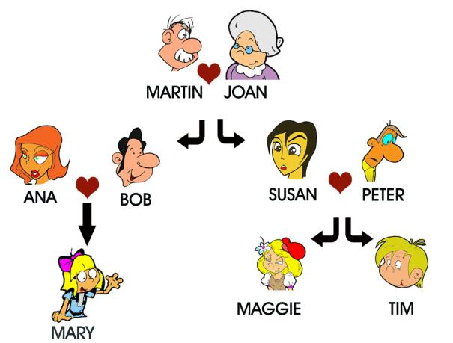

- Susan is Maggie's ________________.
- Martin is Tim's ________________.
- Peter is Mary's ________________.
- Tim is Ana's ________________ .
- Joan is Maggie's ________________.
- Maggie is Tim's _________________.
- Bob is Ana's_________________.
- Mary is Maggie's _________________.
- Mary is Peter's _________________.
- Peter is Tim's___________________.
- Susan is Martin's __________________.
- Tim is Susan's _________________.
- Ana is Bob's _________________ .
- Ana and Bob are Mary's _______________.
Make more sentences!

Ask your friend more questions !
Whose father is Peter? Peter is Tim's father .
Whose daugter is Mary? ___________________

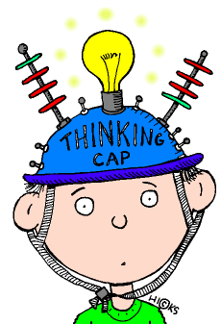
2. Think and answer:
1.She is your mother's mother. She is your...
□ mother
□ aunt
□ grandmother
□ sister
2.He is your uncle's son. He is your...
□ nephew
□ cousin
□ twin
□ grandson

3.She is your grandma's only daughter.She is your...
□ aunt
□ sister
□ mother
□ father

4.He is your mother's son. He is your...
□ brother
□ sister
□ cousin
□ niece

5.She is your uncle's wife. She is your...
□ sister
□ granny
□ mother
□ aunt
6.He is your mother's husband. He is your .
7.He is your brother's son. He is your .
8.Your mother and father are your .
9.He is your father's brother. He is your .
10.She is your father's daughter. She is your .



