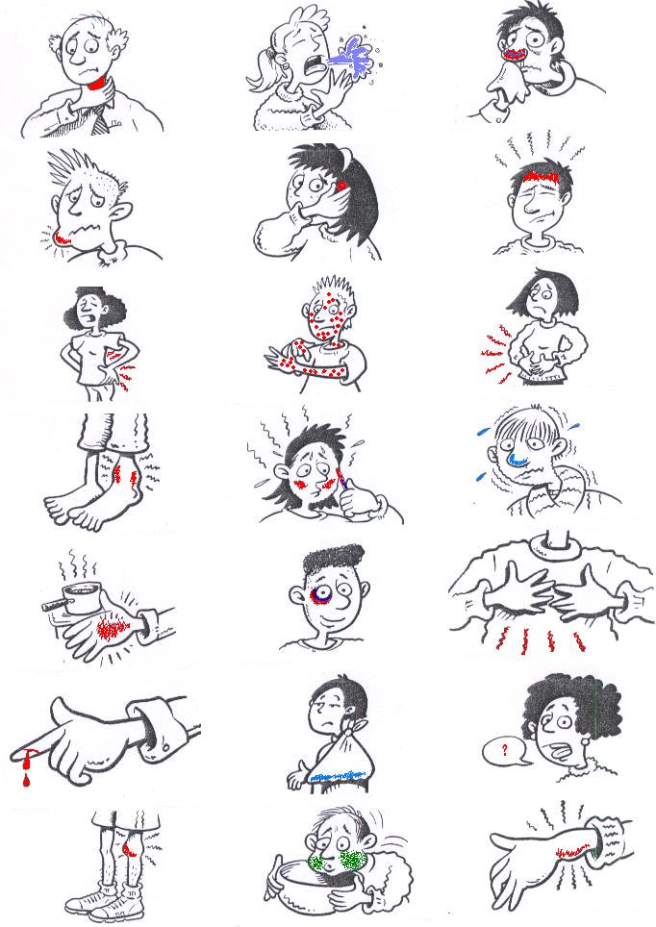

1. I`ve got a sore throat. 2. I`ve got a cough. 3. I`ve got a cold. 4. I`ve got toothache. 5. I`ve got earache. 6. I`ve got a headache. 7. I`ve got backache. 8. I`ve got a rash. 9. I`ve got stomach ache. 10. I`ve got a swollen ankle. 11. I`ve got a temperature. 12. I`ve got flu. 13. I`ve burnt my hand. 14. I`ve got a black eye. 15 I`ve got a pain in my chest. 16. I`ve cut my finger.
I`ve broken my arm.
I`ve lost my voice.
My knee hurts.
I feel sick.
I`ve sprained my wrist.

