[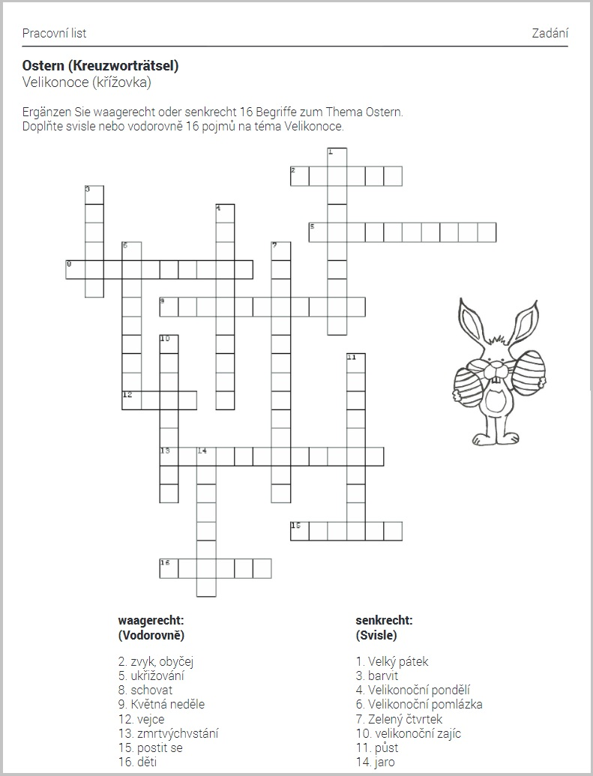](http://www.fraus.cz/mail/3318/link/7ffd107100c34ffb01cc2ccf62f0601c9d98d338?url=https%3A%2F%2Ffred.fraus.cz%2Fqf%2Fcs%2Framjet%2Fknihovna%2F7f54d236110f97a)