

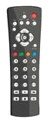
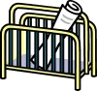

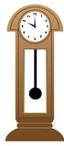
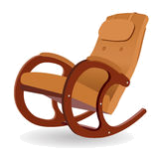

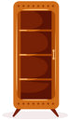



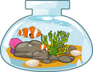
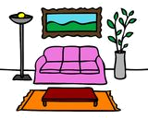
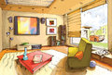
living room
6 Put the letters in the correct order.

1 snketcdialc: _________________
2 tniydclaseabpi:________________
3 knrcgohirica:_________________
4 tfacebfloee:_________________
5 degzemarnoaihl:_______________
6 naehbgbaciar:________________
7 ropflmloa:_________________
8 pvardledy:_________________
9 eailrcpef: _________________
10 nnatpigi:_________________
2 Find ten living room things in the word search.

TVSETDRSANAGTERYOCESRUGPWFKTEVMJONALPTPICTURELOZIHHVESABOOKCASENUPLITSIVTCDPLAYER
1 Match the words and the pictures.
1 display cabinet
2 magazine holder
3 TV set
4 DVD player
5 bookshelf
6 rocking chair
7 clock
8 bean bag chair
9 remote control
10 plant
11 rug
12 painting
a
c
b
d
e
f
h
g
l
i
k
j
3 Find the odd one out.

1 armchair – sofa – rocking chair - bookshelf
2 picture – clock – photo - painting
3 remote control – sound system – CD player – TV set
4 pot – table – aquarium - vase
5 rug – carpet – pot - curtain

4 Complete the sentences with the correct prepositions.

1 The plant is _______ the vase.
2 There is a table __________ the sofa.
3 There is a lamp __________ the sofa.
4 There is a rug ___________ the table.
5 The sofa is _____________ the lamp and the vase.
6 There is a picture ________ the wall.
5 What are they?

1 A soft covering for a floor that is often made of wool and is usually the same size as the floor: ________________
2 A long soft seat for more than one person: _________________
3 A bag filled with something soft; you put it on a chair and you sit on it: ____________________
4 A pot that you put cut flowers in: ____________________
5 A small piece of thick material that you put on the floor: _______
cushion rug vase carpet sofa

key
6 Put the letters in the correct order.

1 snketcdialc: candlestick
2 tniydclaseabpi: display cabinet
3 knrcgohirica:rocking chair
4 tfacebfloee:coffee table
5 degzemarnoaihl: magazine holder
6 naehbgbaciar: bean bag chair
7 ropflmloa:floor lamp
8 pvardledy:DVD player
9 eailrcpef: fireplace
10 nnatpigi:painting
2 Find ten living room things in the word search.

TVSETSAOSRUGPFEMOAPPICTURELHABOOKCASENITCDPLAYER
1 Match the words and the pictures.
1 display cabinet
2 magazine holder
3 TV set
4 DVD player
5 bookshelf
6 rocking chair
7 clock
8 bean bag chair
9 remote control
10 plant
11 rug
12 painting
a
10
11
c
9
b
2
d
e
12
f
7
h
6
4
g
l
1
i
8
k
3
j
5
3 Find the odd one out.

1 armchair – sofa – rocking chair - bookshelf
2 picture – clock – photo - painting
3 remote control – sound system – CD player – TV set
4 pot – table – aquarium - vase
5 rug – carpet – pot - curtain

4 Complete the sentences with the correct prepositions.

1 The plant is in the vase.
2 There is a table in front of the sofa.
3 There is a lamp next to the sofa.
4 There is a rug under the table.
5 The sofa is between the lamp and the vase.
6 There is a picture on the wall.
5 What are they?

1 A soft covering for a floor that is often made of wool and is usually the same size as the floor: carpet
2 A long soft seat for more than one person: sofa
3 A bag filled with something soft; you put it on a chair and you sit on it: cushion
4 A pot that you put cut flowers in: vase
5 A small piece of thick material that you put on the floor: rug
cushion rug vase carpet sofa

