**Label the photos with the types of TV programmes**

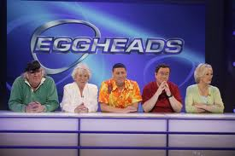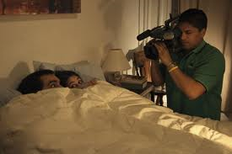weather forecast ◈ quiz show ◈ reality TV ◈ film ◈ nature documentary ◈ the news ◈ sports programme ◈ children’s TV ◈ fashion show



  

  

  